**DATA VISUALIZATION PROJECT**

|  |  |
| --- | --- |
| TOPIC: | TO FIND AND ANALYZE WHICH REGION IN USA HAS MAXIMUM NUMBER OF BAD DRIVERS |
| GROUP NUMBER: | 14 |
| DATASET: | BAD.DRIVERS.CSV |

**COLLEGE OF ENGINEERING**

**NORTHEASTERN UNIVERSITY, BOSTON, MA 02115**

**Description:**

In our visualization project we are taking dataset from National Highway Traffic Safety Administration. Which was available on Github. And we are trying to find that is there any particular region that really has bad drivers and what are factors on which these bad driving skills depends. Is it because of strict traffic rules or because of use of excess alcohol. We will try to analyze the reasons based on our data set and will try to answer the most common questions asked about driving stats across the country.

| **Variables** | **Source** |
| --- | --- |
| States |
| Number of drivers involved in fatal collisions per billion miles |
| Percentage Of Drivers Involved In Fatal Collisions Who Were Speeding |
| Percentage Of Drivers Involved In Fatal Collisions Who Were Alcohol-Impaired |
| Percentage Of Drivers Involved In Fatal Collisions Who Were Not Distracted |
| Percentage Of Drivers Involved In Fatal Collisions Who Had Not Been Involved In Any Previous Accidents |
| Car Insurance Premiums ($) |
| Losses incurred by insurance companies for collisions per insured driver ($) |

Screen-Shot of the data set:

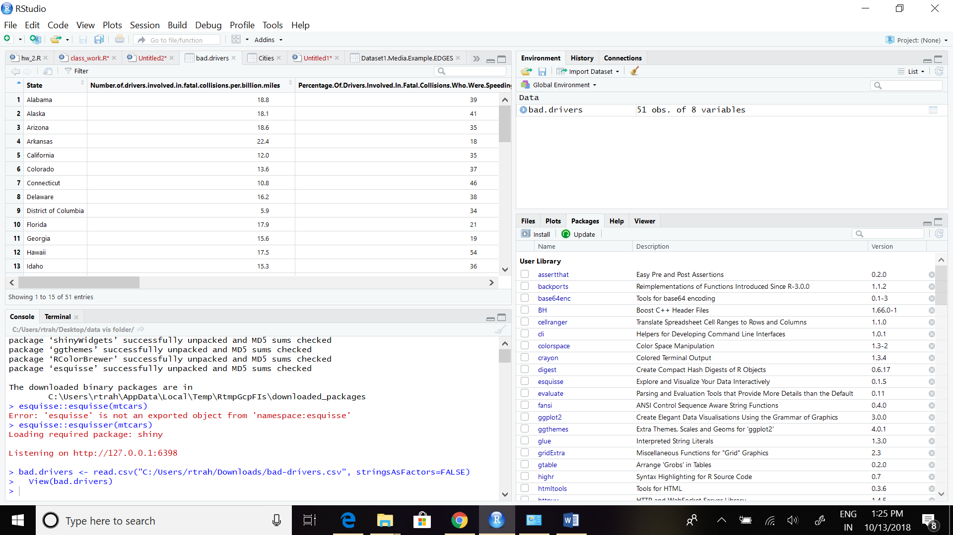

Our dataset has 51 observations with 8 variables.

Bargraph to get the state with maximum collisions

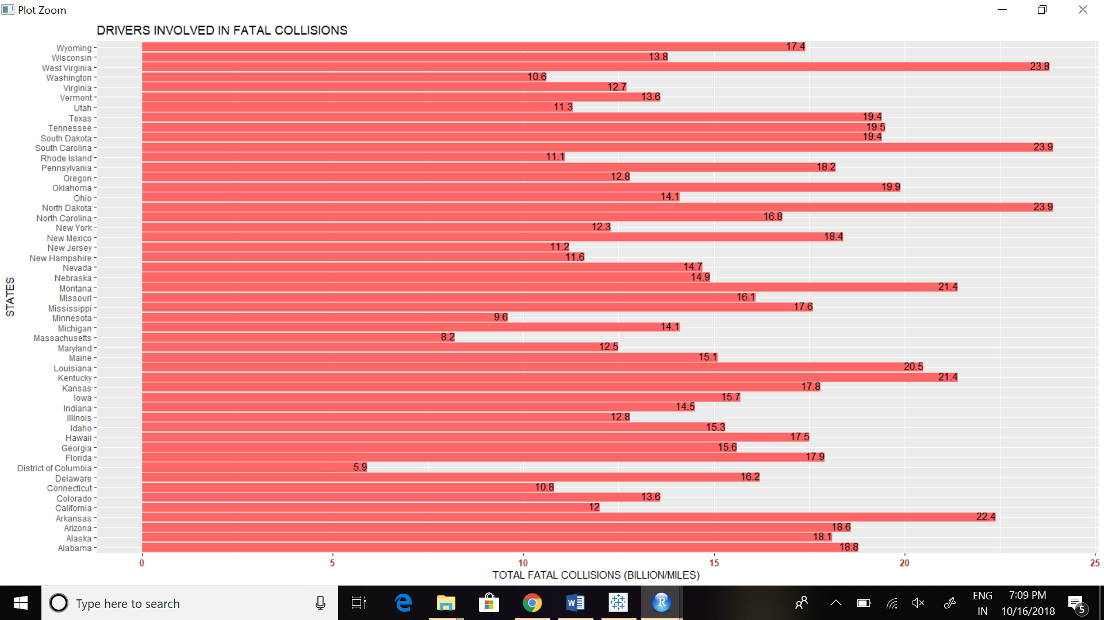

Source: [National Highway Traffic Safety Administration](http://www-fars.nhtsa.dot.gov/Main/index.aspx) (NHTSA).

From the above graph we can see that the highest fatal collisions were in the state of North Dakota and South Carolina But a state with more fatal car crashes is not necessarily a state with more bad drivers it could simply be a state that has more drivers or a state with worse driving conditions.

From the above graph we can take data of the first five states having the most collisions and we can look for factors which play a major role in this. Drunken driving is a good indicator who is a bad driver. [31%](http://www-nrd.nhtsa.dot.gov/Pubs/811856.pdf) of all traffic fatalities in 2012 occurred while a driver was alcohol-impaired.

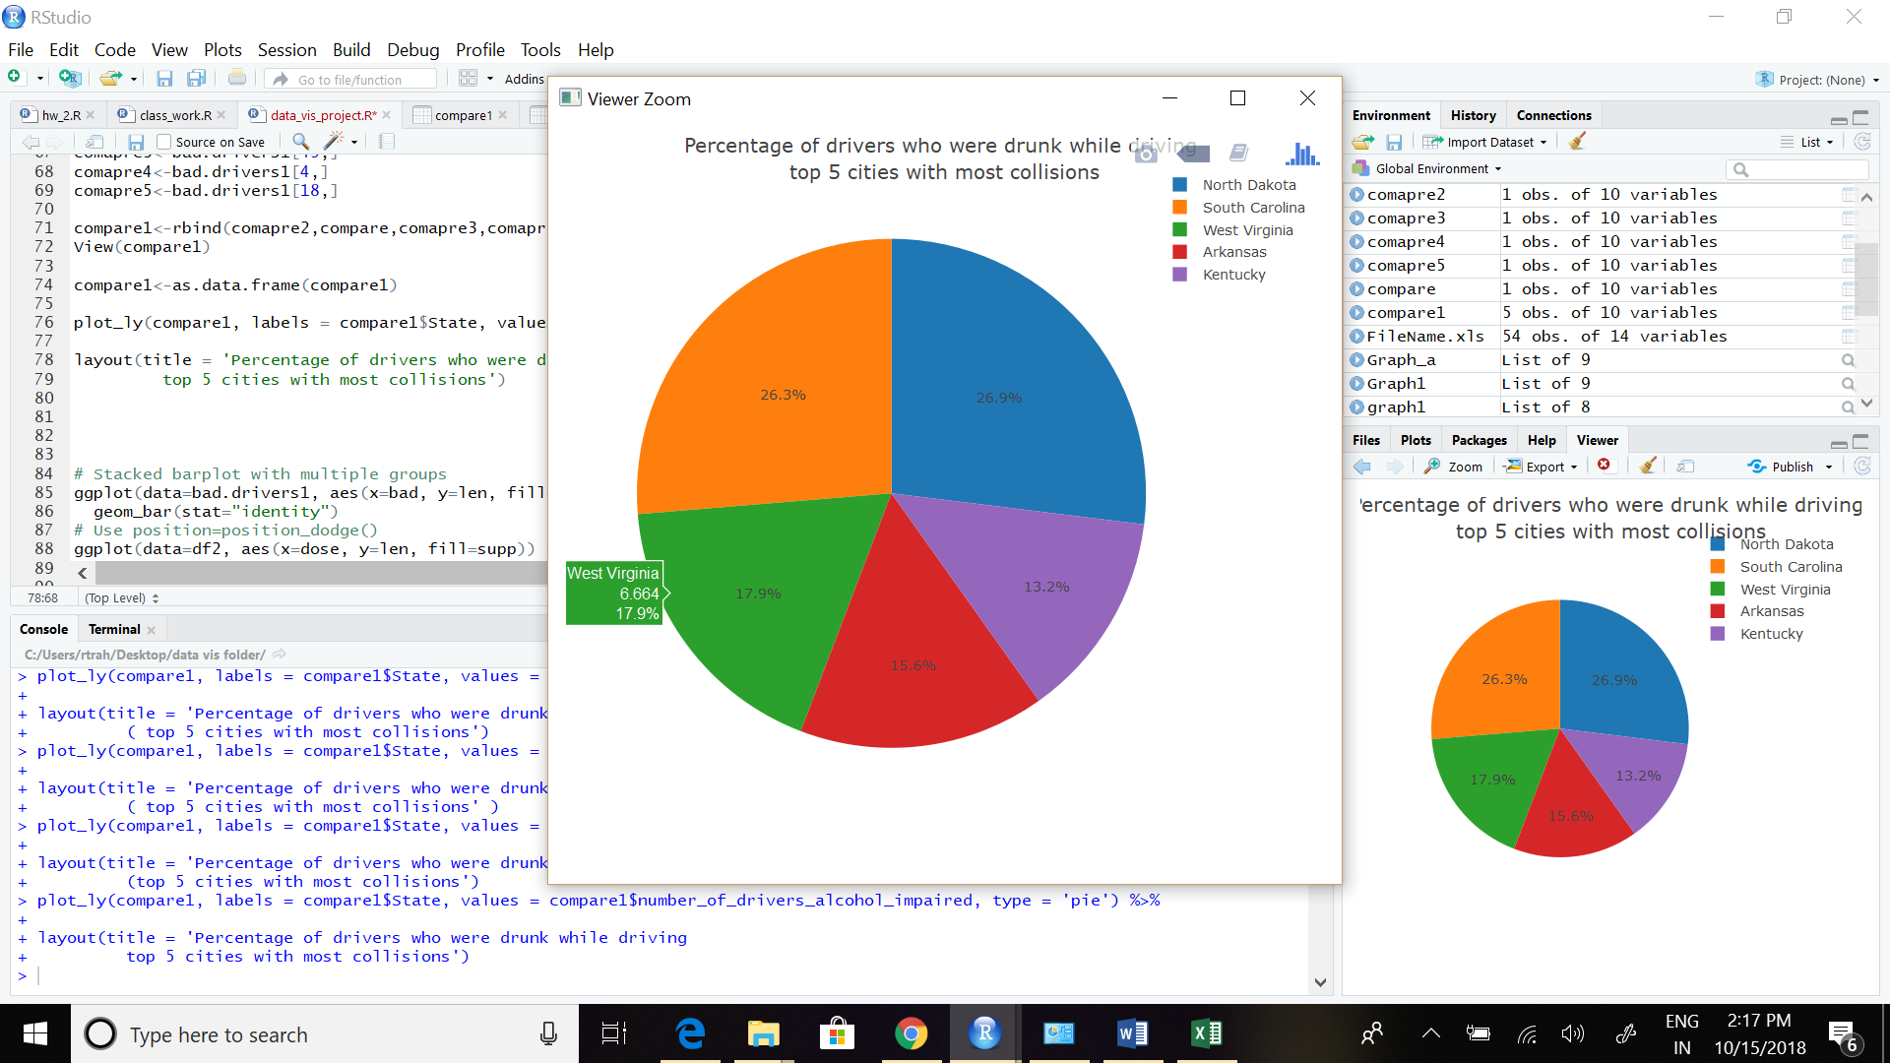

From the above interactive pie chart we can see that the number of drivers who are innvolved in fatal collisions while under the infulence of alcohol are also highest in the state of north dakota and south carolina. We can conclude that alcohol is a major factor in collisions and drivers in these states tends to drink and drive more comapared to other states in the usa.

Another factor for determining these fatal crashes are speeding. Drivers tend to drive in more speed and the NHTSA recorded 33,808 total traffic fatalities, 31% of which occurred while a driver was speeding.

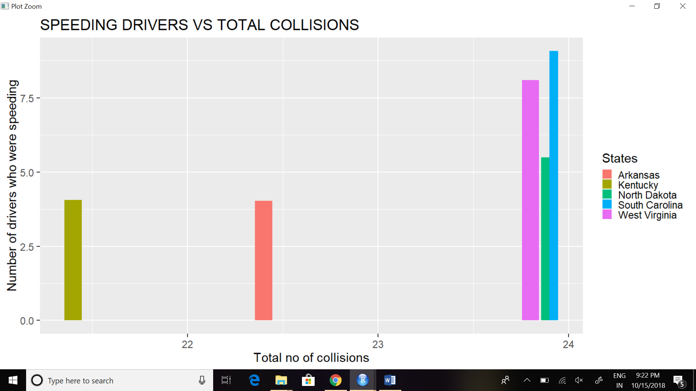

Source: [National Highway Traffic Safety Administration](http://www-fars.nhtsa.dot.gov/Main/index.aspx) (NHTSA).

From the above graph of the top states with the most number of collisions we can see that speeding problem is maximum in the state of South Carolina while the state of North Dakota there are around 6 drivers which accounts for the 23% of the total. While for the South Carolina it is 38%. So, we can conclude that although speeding is a major factor, but we cannot say it is solely the factor for collisions. It is mis-conception among public that driving in more speed often leads to accident.

Premiums Vs Losses incurred:

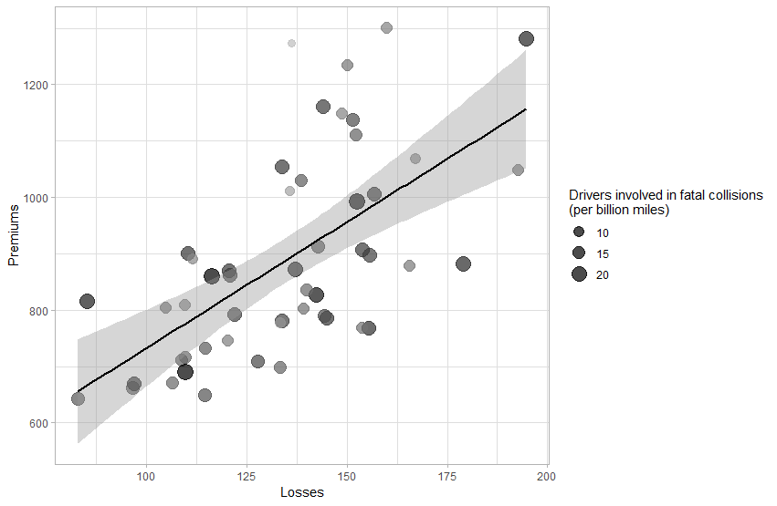

Scatter plot: Average insurance premiums vs. average losses among different states

As we can see from the plot above, there is a certain pattern between the insurance premiums and losses caused in car accident, if the average loss is high, the premium will be high too, which make perfect sense. We add a linear regression to it weighted with the total number of drivers involved in the fatal collisions among different states.

Code

ggplot(CarDeath,aes(x = Losses, y = Premiums))+

geom_point(aes(size = DR, color = DR), alpha = 0.7)+

geom_smooth(aes(size = DR), method = lm, size = 1,color = "black")+

scale_colour_gradient(low = "grey", high = "black", guide = "none")+

scale_size_area("Drivers involved in fatal collisions\n(per billion miles)")+

theme_light()

From Visualization of the Loss that is suffered by the insurance companies because of the accidents. We can aslo take a look at the best drivers amongst all the states in the country. And which states are most profitting for the companies.

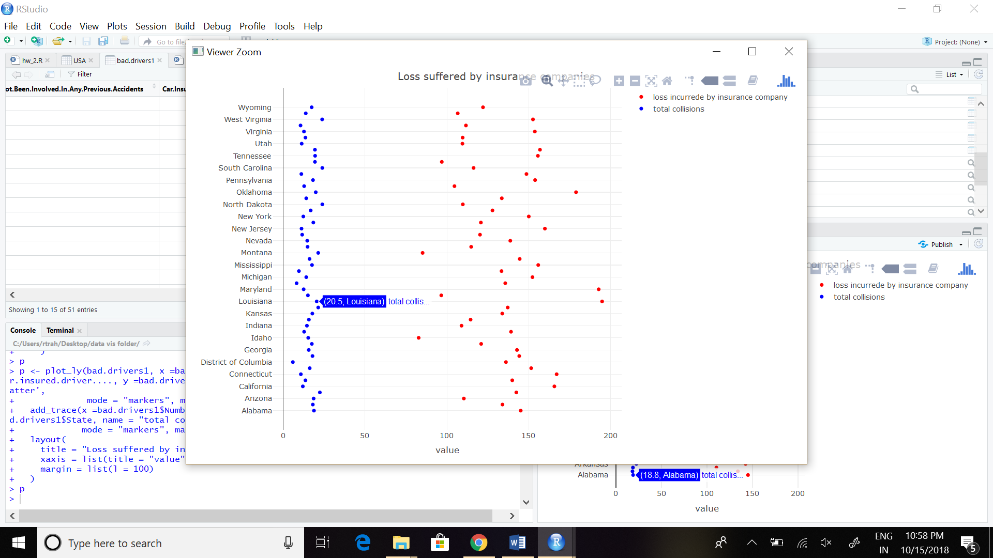

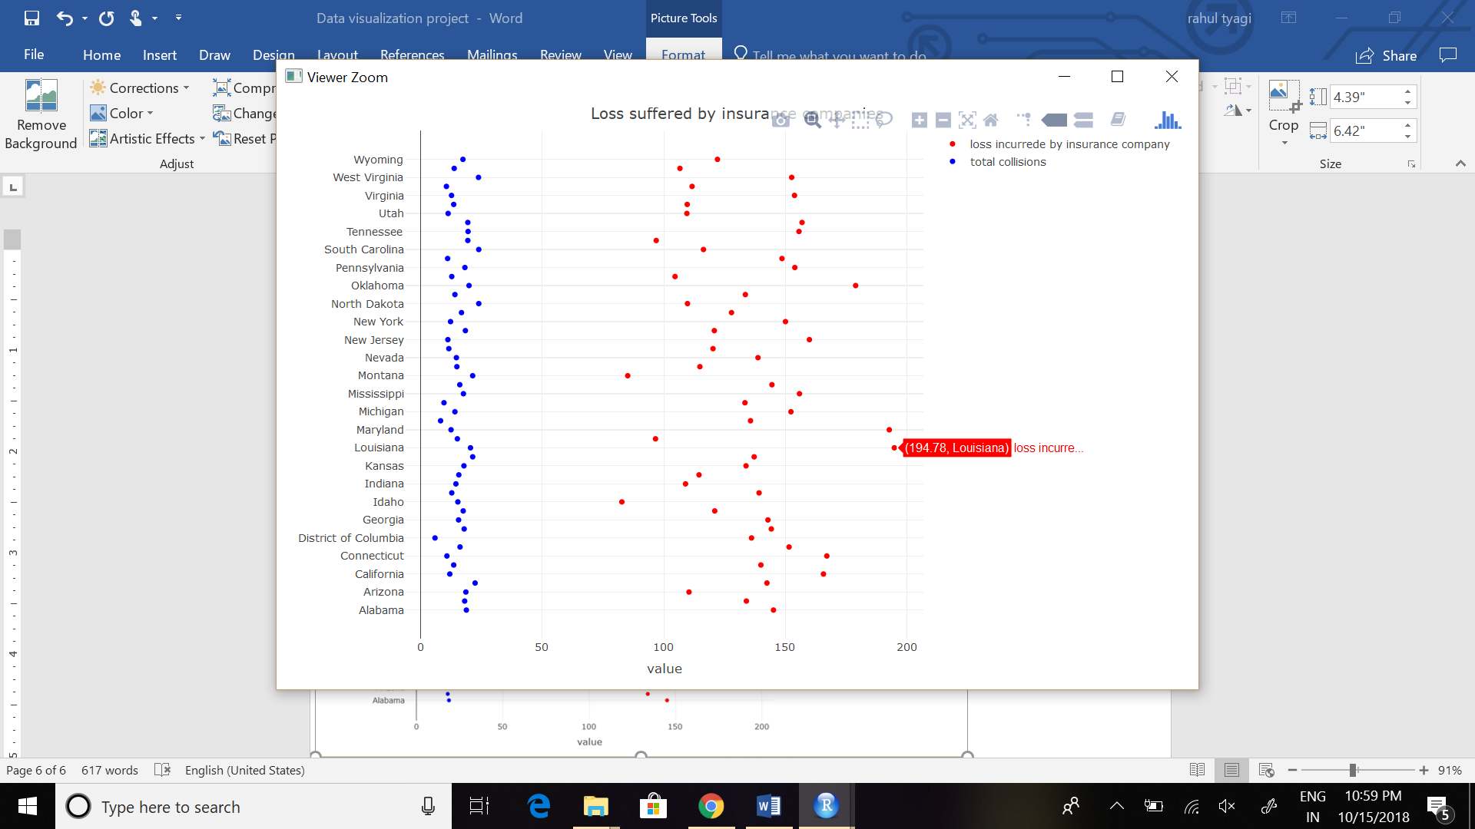

From the above two graphs we can clearly see that the states with highest number of collisions are not the ones who are giving major trouble to insurance companies. In fact louisiana which has comparable less number of collisions per billion miles are costing most to the insurers. Idahoans come out as America’s best drivers. According to this analysis we can say that drivers in states like north dakota, south carolina are not the worst for the insurance companies.

Animated graph

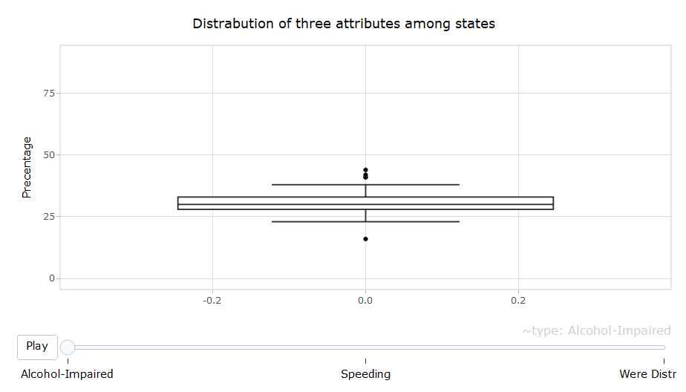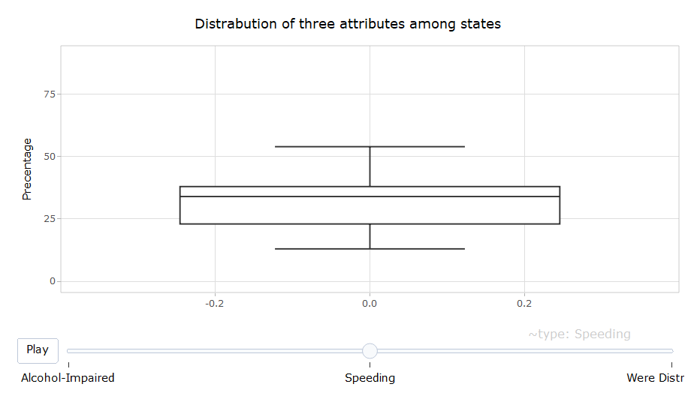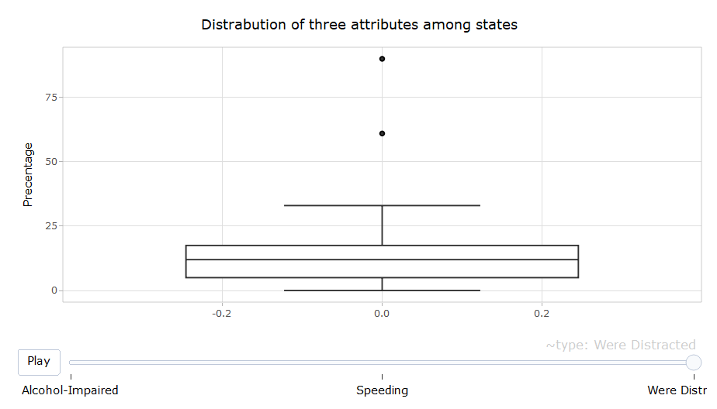Animated graph1:

Using Plot_ly package generating animated graph. We can clearly find out the distribution of using alcohol, overspeed, being distracted while driving among different states. As we can see from the above animated graph, there are an average 25% speeding rate among drivers with a small standard error, meanwhile the overall distracted rate is low with several outliers.

# 

Animated graph 2:

This graph focus on the top ten states with the highest overall fatal collisions rate, by comparison, the most dominant factor is whether drivers were alcohol-impaired at the time of driving, and speeding is another key factor.

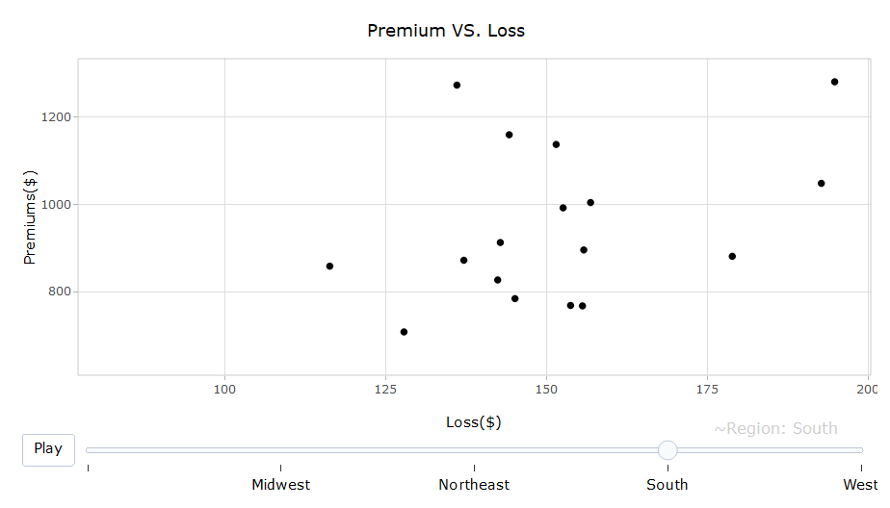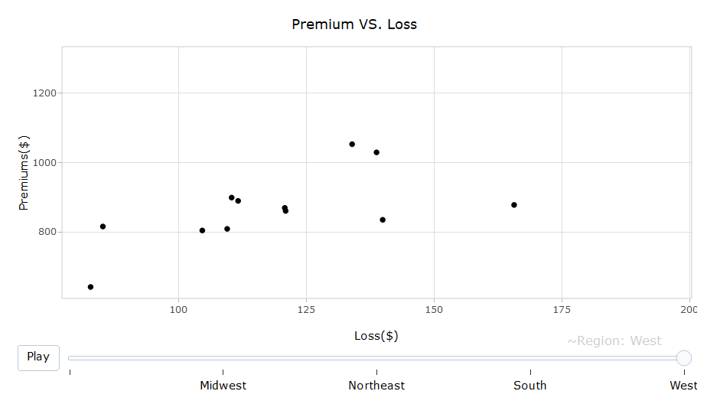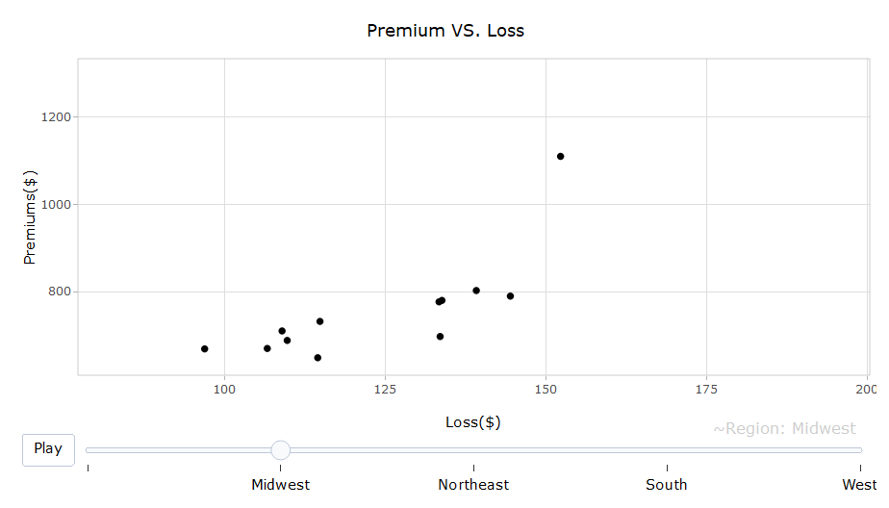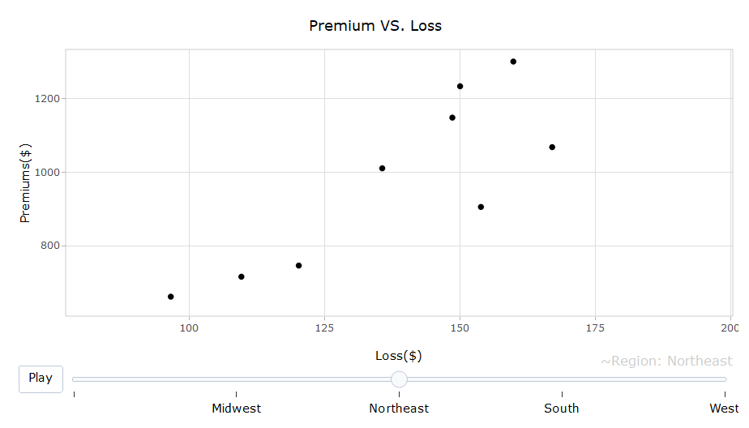As we can see from this animated chart, after combining different states into regions, the Northeast Region and South region generally has a higher premium rate than the other two regions, in the West region, we cannot see a linear relation between the two variables, in another word, the premium rate is influent by factors other than the average loss of car damages.

Conclusion:

From our visualization and analysis, we can say there is no clear-cut way to determine the state with the most number of bad drivers. But we can say that judging drivers on a specific scale or criteria is also not feasible as we saw that for the insurance companies the state of North Dakota was not a problem in-fact it is one of the most profitable state for insurance companies. Many of our mis-conceptions also got cleared while doing this visualization like over-speeding is not the only factor for determining bad drivers. And surprisingly Louisiana has the most number of insurance accidental cases. Every state has some bad drivers and some good drivers and there are numerous factors which has to be taken into consideration for judging drivers.